Harnham Infant School

3 YEAR PUPIL PREMIUM STRATEGIC PLAN

Organisation
The Pupil Premium Strategic Plan is organised into 3 sections and based on the long-term approach to Pupil Premium planning recommended by the DfE and the Education Endowment Foundation (EEF).
Section | Focus | Contents
Section 1 | School context & approach to the PPG | Philosophy, school context & barriers to learning, implementation, review and accountability
Section 2 | Long term (3 year) overview | Setting long term goals to reflect the school context
Section 3 | Academic Year Action Plan & Impact Statement | Action plan for the current academic year, funding and evaluation of impact

SECTION 1
SCHOOL CONTEXT & APPROACH TO THE PUPIL PREMIUM GRANT (PPG)

PHILOSOPHY & PRACTICE
We believe in maximising the use of the Pupil Premium Grant (PPG) by utilising a long-term strategy which is fully aligned to our School Development Plan. This enables us to implement a blend of short, medium and long-term interventions, which effectively coordinate use of Pupil Premium and wider school improvement strategies for maximum impact on pupil outcomes.
We build our practice around the 7 areas of principle (below) and have adopted the Education Endowment Foundation (EEF) recommended ‘tiered’ approach to define our priorities and ensure balance. Our tiered approach comprises three categories: Teaching, Targeted Academic Support & Wider Strategies.
Area of Principles | School Practice
Whole-school ethos of attainment for all | Have an ethos of attainment for all pupils and avoid stereotyping disadvantaged pupils as all facing similar barriers or having less potential to succeed.
Addressing behaviour and attendance | Ensure effective behaviour strategies are in place, respond quickly to poor attendance and provide strong social and emotional support, including through working with families
High quality teaching for all | Emphasise and deliver ‘quality first teaching’ and provide consistently high standards by setting expectations, monitoring performance and sharing best practice
Meeting individual learning needs | Identify each pupil’s challenges and interests. Seek the best strategies to help each pupil make the next step in his or her learning. Provide individual support for specific learning needs and group support for pupils with similar needs.
Deploying staff effectively | Devolve responsibility to frontline staff, use our best teachers to work with pupils who need the most support and train Teaching Assistants to effectively support pupils’ learning.
Impact driven and responsive to evidence | Effectively use data, and other evidence, to identify pupils’ learning needs, review progress regularly and address underperformance quickly. Have manageable Assessment for Learning systems, which provide clear feedback for pupils. Use evidence to make decisions about support strategies.
Ambitious leadership | Have high aspirations and lead by example. Hold all staff accountable for raising attainment and do not accept low aspirations and variable performance. Be aware of best practice within, and beyond, the school and invest in staff training.

The following tables support understanding of our school context and are used to identify areas of strength and development (long, medium and short term)
OVERVIEW OF SCHOOL CONTEXT
Characteristic | EYFS PP | EYFS non-PP | Year 1 PP | Year 1 non-PP | Year 2 PP | Year 2 non-PP | Year 3 PP | Year 3 non-PP | Year 4 PP | Year 4 non-PP | Year 5 PP | Year 5 non-PP | Year 6 PP | Year 6 non-PP
Year Group | 8  (11%) | 66  (89%) | 6  (12%) | 46  (88%) | 6  (9%) | 64  (91%)
Boys | 3  (4%) | 33  (45%) | 2  (4%) | 26  (50%) | 3  (4%) | 37  (53%)
Girls | 5  (7%) | 33 (45%) | 4  (8%) | 20  (38%) | 3  (4%) | 28  (40%)
SEN Support | 2  (3%) | 5  (7%) | 2  (4%) | 3  (6%) | 0  (0%) | 5  (7%)
EHC Plan | 2  (3%) | 2  (3%) | 0  (0%) | 0  (0%) | 1  (1%) | 1  (1%)
EAL | 0  (0%) | 9  (12%) | 1  (2%) | 8  (15%) | 0  (0%) | 12  (17%)

ASSESSMENT DATA
EARLY YEARS FOUNDATION STAGE (EYFS) 2019
 | All pupils | Pupils eligible for Pupil Premium | Pupils not eligible for Pupil Premium | National average | School data from previous 3 years
 |  |  |  |  | 2017 - 18 | 2018 - 19 | 2019 - 2020
Good Level of Development (GLoD) | N/A | 7 | 39 | N/A | 71.1% (HIS)  72.1% (LA)  71.5% (NA)  0.00% (PP) | 76.1% (HIS)  72.3% (LA)  71.8% (NA)  0.00% (PP) | n/a
Reading | N/A | 7 | 39 | N/A | 79% (HIS)  67% (PP) | 84% (HIS)  0% (PP) | n/a
Writing | N/A | 7 | 39 | N/A | 71% (HIS)  50% (PP) | 79% (HIS)  0% (PP) | n/a
Number | N/A | 7 | 39 | N/A | 71% (HIS)  50% (PP) | 84% (HIS)  0% (PP) | n/a

2017 – 2018 = 6 children
2018-2019 = 1 child
2019-2020 = 7 children

YEAR 1 PHONICS SCREENING CHECK
All pupils | Pupils eligible for Pupil Premium | Pupils not eligible for Pupil Premium | National average | School data from previous 3 years
 |  |  |  | 2017-18 | 2018-19 | 2019-20
N/A | 3 | 69 | N/A | 85.3% (HIS)  No data (PP) | 79.1% (HIS)  No data (PP) | n/a

END OF KEY STAGE ONE (KS1)
 | All pupils | Pupils eligible for Pupil Premium | Pupils not eligible for Pupil Premium | National average | School data from previous 3 years
 |  |  |  |  | 2017 - 18 | 2018 - 19 | 2019 - 20
% achieving expected standard or above in Reading, Writing and Maths | N/A | 9 | 79 | N/A | 56.2% (HIS)  72.3% (LA)  73.8% (NA) | 57.0% (HIS)  72.3% (LA)  72.6% (NA) | n/a
% making expected progress in Reading | N/A | 9 | 79 | N/A | 60.7% (HIS)  75.4% (LA)  75.4% (NA)  60% (PP) | 73.4% (HIS)  75% (LA)  75% (NA)  38% (PP) | n/a
% making expected progress in Writing | N/A | 9 | 79 | N/A | 60.7% (HIS)  68.2% (LA)  69.9% (NA)  60% (PP) | 65.8% (HIS)  68% (LA)  69% (NA)  38% (PP) | n/a
% making expected progress in Maths | N/A | 9 | 79 | N/A | 74.2.0% (HIS)  73.3% (LA)  76.1% (NA)  80% (PP) | 75.6% (HIS)  74% (LA)  76% (NA)  38% (PP) | n/a

2017-2018 = 10
2018-2019 = 13
2019-2020 = 9
ATTENDANCE
 | All pupils | Pupils eligible for PP | Pupil not eligible for PP | National average (2018/2019) | School Data from previous 3 years
 |  |  |  |  | 2017-18 | 2018-19 | 2019-20
Overall absence | N/A | 9 | 79 | 4.0% | 4.2%  1.85% (PP) | 3.4%  2.73%(PP) | n/a
Unauthorised absence | N/A | 9 | 79 | 1.1% | 1.23%  2.77% (PP) | 1.17%  3.33% (PP) | n/a
Persistent absentees | N/A | 9 | 79 | 8.2% | 7.1% | 6.4% | n/a

BEHAVIOUR
 | All pupils | Pupils eligible for PP | Pupils not eligible for PP | National average 2018/2019 |  |  | School Data from previous 3 years
 |  |  |  | All | PP | Non-PP | 2017-18 | 2018-19 | 2019-20
% Permanent Exclusions | 88 | 9 | 79 | 0.1 | 0.27 | 0.06 | 0 | 0 | 0
% Fixed Term Exclusions | 88 | 9 | 79 | 5.36 | 13.76 | 3.83 | 0 | 0 | 0
Incidents on CPOMS | N/A | N/A | N/A |  |  |  | 0 | 0 | 0

SAFEGUARDING
 | All pupils | Pupils eligible for PP | Pupils not eligible for PP | School Data from previous 3 years
 |  |  |  | 2017-18 | 2018-19 | 2019-20
Number of Referrals | 5 | 2 | 3 | 5 | 7 | 5
% Child Protection (CP) | 0 | 0 | 0 | 1 | 0 | 0
% Child in Need (CiN) | 1 | 0 | 0 | 1 | 1 | 1
% LAC | 2 | 2 | 0 | 2 | 3 | 2
% Early Help | 2 | 2 | 0 | 4 | 5 | 2

SUMMARY OVERVIEW OF SCHOOL BARRIERS (ACADEMIC & NON-ACADEMIC) IDENTIFIED TO ADDRESS THROUGH THE PUPIL PREMIUM GRANT (PPG)
- Raising expectations and having high aspirations for progress of all pupils.
- Consistently championing the attainment and achievement of Disadvantaged Learners and getting the whole staff team, including governors, to feel the moral imperative to ‘buy in’ and not have any excuses.
- Ensuring that all teaching is consistently good or better over longer periods of time.
- Children building the stamina, self-esteem and self-regulation needed for learning to be maximised, not giving up or opting out.
- Children having good role models for language and listening and attention skills.
- Children facing challenges at home such as relationship breakdowns, mental health issues etc.
- Parental support with home learning, such as reading, talking and spelling is lower for some families.
- Children experiencing a lack of aspiration at home, therefore not seeing the value of education for themselves. Some children therefore also suffer with low attendance rates or are frequently late.
- Parents lacking on own literacy skills themselves so feeling unable to support their children.
- Children experiencing low self-esteem and wellbeing, or facing issues related to attachment or trauma, especially in response to the Covid-19 pandemic.
- Children not always having the correct equipment to be able to take part in lessons and activities effectively.

IMPLEMENTATION PROCESS
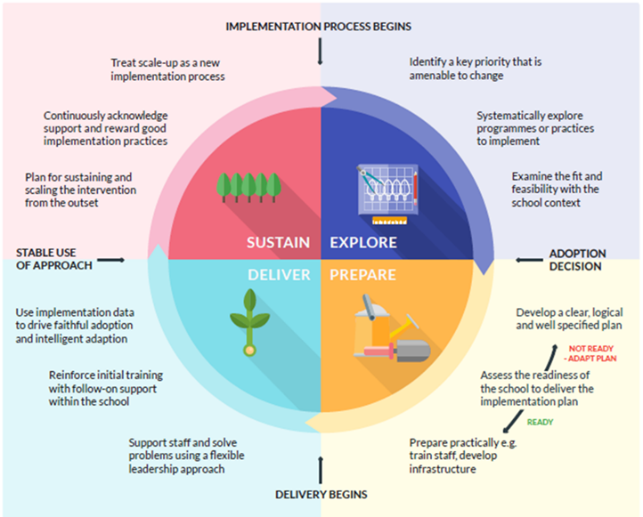

We believe in selecting a small number of priorities and giving them the best chance of success. We use the EEF Implementation Process Wheel to support and inform the development of our strategic Pupil Premium plans. In our implementation, we will:
Explore: what problems are we seeking to solve in the academic year? Are there adequate solutions, in the form of evidence-informed practices or programmes?
Prepare: do we have a clear, logical and well-specified plan? Do staff fully understand what is being implemented and how? What is the readiness of the school and staff to undertake these changes?
Deliver: how best can staff best deliver upon new approaches? Are there mechanisms in place to improve their use over time? Can we reinforce our approaches with initial training and continuous wrap around support?
Sustain: how do we best maintain new practices, for both staff and pupils, across a full academic year? How we will nurture motivation and ensure that we acknowledge and support good practice?

OUR REVIEW PROCESS
We believe in evidence-based interventions and learning from our experiences, which is why we carry out termly Pupil Premium progress review meetings, and on-going checks during interventions to ensure clear progress from a pupil’s baseline and towards end of year objectives. To ensure our approach is effective, we will cease or amend any interventions that are not having the intended impact. The progress of pupils in receipt of the PPG is regularly discussed (termly) with teachers at pupil progress review meetings. At the end of each year, we fully evaluate the impact of all our actions and strategies on pupil outcomes and use this information to inform next steps.

The impact of the action/intervention is: | Far above expectations |  | Above expectations |  | As expected |  | Below expectations |  | Far below expectations

ACCOUNTABILITY
The Local Governing Body has an allocated Governor with oversight of the impact of the Pupil Premium Grant (PPG) and outcomes for pupils. Governors will scrutinise the school’s strategy for using the Pupil Premium Grant on an annual basis as well as monitoring the attainment and progress of disadvantaged pupils during the course of any academic year.
The Headteacher and Pupil Premium Leader will be accountable for securing high standards and positive outcomes for all pupils in receipt of the PPG and, often, Performance Management for all school staff will reflect this priority.
Ofsted inspections will report on the attainment and progress of disadvantaged pupils in receipt of the PPG.
The school is held to account for the spending of the PPG through the focus in Ofsted inspections on the progress and attainment of the wider pupil premium eligible cohort; however, they will not look for evidence of the grant’s impact on individual pupils, or on precise interventions.
The school annually publishes its strategy for using the Pupil Premium Grant (PPG) on the school website.

FUNDING

SECTION 2: LONG TERM (3 YEAR) OVERVIEW
SETTING THE PRIORITIES
Setting priorities is key to maximising the use of the PPG. Our long term priorities are identified in our 3 year strategic overview and progress towards them outlined in a detailed action plan relevant to each academic year (see Section 3). When establishing our priorities, we draw on research and evidence to understand strategies that will have maximum impact on pupil outcomes and relate them to the EEF tiered approach.
HEADLINE AREAS FOR DEVELOPMENT 2020 – 2023
PP AREA FOR DEVELOPMENT | TIERED FOCUS AREA, RESEARCH & EVIDENCE | PP DESIRED OUTCOME
Raise standards in EYFS and KS1 to at least the same attainment levels as non-PP pupils | Teaching & Targeted Academic Support  Small group tuition +4 months  1:1 tuition +5 months  Oral language interventions +5 months  Feedback +8 months | By the end of EYFS and KS1, the percentage of PP pupils achieving the expected standard in Reading, Writing and Maths will be at least the same as non-PP pupils. This will be in line with, or above, the national average consecutively and rising.
Raise levels of accountability for the progress of PP pupils for all stakeholders. | Teaching & Targeted Academic Support | Children will be discussed at PP pupil progress meetings and all stakeholders involved know what is being put into place for each individual child to help them to learn.  Tracking documents and individual profiles of pupils will be utilised as evidence for what works for each child and strategies adapted or changed as often as necessary in order to maximise learning for each child.
Improve children’s skills in metacognition and self-regulation. | Wider Strategies  Metacognition and Self-Regulation +7 months | Children will develop a Growth Mindset and embed this through the school culture. They will be reflective learners who develop stamina, remain motivated and do not give up. Children will not put a ceiling on their learning.  Children will be able to describe what helps them to learn and then independently use these strategies.
Ensure that children attend school every day, on time, behave well and know how to keep themselves safe. | Wider Strategies  Social and emotional learning +4 months  Parental Engagement +3 months | Children in receipt of PP will have an attendance rate that is at least in line with non-PP children.  Children will attend school and be on time each morning.  Any incidents of behaviour, including low-level classroom behaviour will be lowered.  Children can explain how they keep safe at school and know what to do if they are worried about anything.  Children will have access to high quality provision of our school ELSA to enable them to be mentally healthy and happy.  Families to have access to high quality provision of our school PSA to enable parents to feel supported themselves and therefore able to meet children’s needs.
Ensure equal opportunities for all children including Disadvantaged Learners. | Wider Strategies | Every child to have the same opportunities in schooling as their peers. This could be with financial contributions to school trips and educational visits, to take part in extra-curricular activities and have all equipment needed for specialist lessons e.g. recorders.  PSA support to be utilised by Disadvantaged families in order to be able to access all sources of support available to them where needed e.g. housing, financial support, referral to other services etc.

SECTION 3: ACADEMIC YEAR 2020/2021 ACTION PLAN & IMPACT STATEMENT

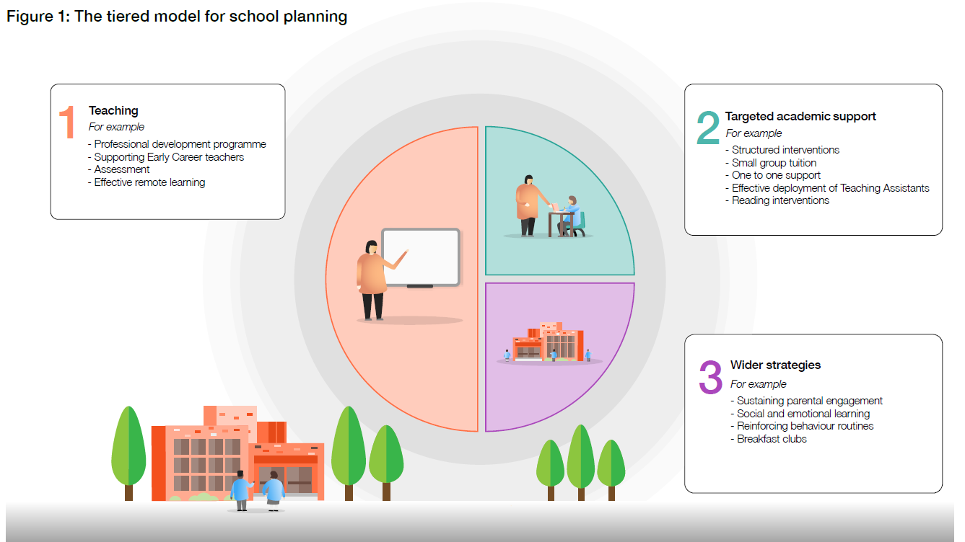
Areas for development reflect the EEF tiered model approach and support achievement of the school 3 year strategically planned outcomes:
Tier 1 Teaching: Objectives that ensure effective teaching in every class and support teachers to keep getting better (Professional development; Training; Support for Early Career teachers; Recruitment and retention)
Tier 2 Targeted Academic Support: Objectives that link interventions to support classroom teaching, and includes teachers and Teaching Assistants (Structured interventions; Small group tuition; 1:1 support)
Tier 3 Wider Strategies: Objectives that relate to the most significant non-academic barriers to success in school, including attendance, behaviour and social and emotional support. Linked to the needs of the community (Behaviour strategies; Breakfast Club; Increasing attendance)

LINKED TO 3 YEAR STRATEGIC OUTCOME: |  |  | Raise standards in EYFS and KS1 to at least the same attainment levels as non-PP pupils
ACADEMIC YEAR 2020/2021 OBJECTIVEs: |  |  | To ensure that teaching in all year groups and subject areas is consistently good or better.  To use effective interventions to raise standards in Oracy.
AREA OF SPEND | PP SPEND | RESPONSIBILITY | DESCRIPTION OF ACTIONS & TIMINGS | INTENDED OUTCOMES & EVIDENCE | IMPACT
Coaching | £4,000 | ND, LP | Coaching programme to be utilised from term 2 (starting in year group bubbles)  Teachers to be given release time to carry out the coaching programme and allow times for meetings to be set. | Children to be receiving consistently good or better teaching.  Teachers being reflective and developing their practice in line with children’s skills, knowledge and interests. (Staff survey after each round of coaching)  Attainment data will rise.  Progress seen through other monitoring activities e.g. book looks, learning walks etc.
Oracy | £10,000 | LP | School signed up to The Nuffield Early Language Intervention programme. Accepted place Nov 2020  Dec 2020 – Staff to attend the training and receive the resources in order to run the programme. Cost of supply cover to release staff to attend the training required.  Dec 2020 – All EYFS children to be screened using the app to find out which children will benefit the most from the programme.  Jan – July 2021 – NELI programme to be delivered to the children and progress measured from their starting points.  Employment of support staff or paying additional hours to deliver the programme and organise it effectively. | Children to be able to speak in sentences and enhance their vocabulary and ability to express themselves.  Progress measured throughout the programme.  Feedback also from teacher’s observations in class and how the children are progressing e.g. on Tapestry, feedback at pupil progress meetings etc.
Speech and Language | £2,800 | LP | Employment of additional teaching assistant to support the children who need Speech and Language Therapy support. Many of these children are in receipt of Pupil Premium. (See SaLT TA timetable for further details) | Children will be meeting their targets, targets reviewed and ultimately signed off from Speech and Language support.  Children who benefit from additional support with communication will be able to take part in Speaking and Listening interventions e.g. Talk Boost, Lego Therapy, EAL groups etc.
Training and Development for all staff e.g.Walk Thru’s, Online broadcasts | £5,000 | ND | All staff to have access to high quality training.  Teachers to work through the “Walk-Thru’s” in order to maximise the consistency and effectiveness of our practice.  Other training opportunities as they arise e.g. Wiltshire Council courses currently being offered online | Staff knowledge will be kept up to date with current national and local developments. This can then be implemented where appropriate in our school.  Evidence shown in culture of school and staff meetings.
Support Staff | £8,000 | LP | Employment of additional teaching assistant for classes that currently have no additional support.  TA to work for 3 mornings per week to run targeted interventions for children e.g. fiddly fingers, phonics etc. (See provision maps for details) | Raised attainment data at data drops.  Progress reviewed at pupil progress meetings.  Other monitoring activities such as book looks, intervention folders, learning walks etc.
Curriculum and Feedback | £2,000 | FS | Review school curriculum in response to Covid-19, adapt teaching focus and purchase any additional high quality resources needed.  Explore effectiveness of school Feedback policy and strategy and change and adapt this to support children further. | Adapted Long term and Medium term plans with skills and knowledge coverage to plug any gaps from the school closures during Covid-19.  Children to understand what the school’s marking policy means and to use this to inform their learning and next steps.  Evidence from book looks, pupil voice and reflections at PDMs etc.

LINKED TO 3 YEAR STRATEGIC OUTCOME: |  |  | Raise levels of accountability for the progress of PP pupils for all stakeholders.
ACADEMIC YEAR 2020/2021 OBJECTIVE: |  |  | For all members of school staff and governing body to know who the PP pupils are and what strategies are being used to raise attainment for these pupils.
AREA OF SPEND | PP SPEND | RESPONSIBILITY | DESCRIPTION OF ACTIONS | INTENDED OUTCOMES & EVIDENCE | IMPACT
Leadership of Disadvantaged Learners | £8,000 | LP | Appointed Disadvantaged Learner lead in school to take responsibility of the strategy and ensure the implementation of agreed tools and techniques.  Regular (termly) meetings with Disadvantaged Learner Link Governor to ensure accountability of the role.  Carry out the role requirements as per the Wiltshire Council job description for Disadvantaged Learner Leader.  Lead regular PDM meetings about Disadvantaged Learners to give overview of local and national developments, strategies and ideas.  Carry out additional pupil progress meetings specifically about Disadvantaged Learners and use tracking documents to show what support is in place and progress towards targets.  Use of EEF audits to ensure that strategies being used are the most effective. Change or adapt where needed.  Tracking of Disadvantaged Learners to be separated from Disadvantaged Learners with additional SEN needs to gain clearer picture of impact of initiatives to remove barriers. | Profile of Disadvantaged Learners to be raised dramatically. Every member of staff in the school will be able to identify who the disadvantaged learners are and, where appropriate, be able to discuss what support is currently in place for them.  Teachers and Teaching Assistants will be able to talk knowledgably about Disadvantaged Learners, reflect on their progress and suggest future targets and possible strategies.  Evidence found in notes from Disadvantaged Learner pupil progress meetings (x3 additional meetings per year) and minutes from every PDM where updates included in the agenda.  Completion of audits and Wiltshire Council Matrix to give ideas for further development.

LINKED TO 3 YEAR STRATEGIC OUTCOME: |  |  | Improve children’s skills in metacognition and self-regulation
ACADEMIC YEAR 2020/2021 OBJECTIVE: |  |  | Children to show high levels of engagement in their learning and be motivated to learn and improve.
AREA OF SPEND | PP SPEND | RESPONSIBILITY | DESCRIPTION OF ACTIONS | INTENDED OUTCOMES & EVIDENCE | IMPACT
Growth Mindset | £1,000 | ND | Children to take part in regular Growth Mindset assemblies and enhance this through lessons where children are encouraged to reflect on their learning and whether they are using their growth mindsets.  Growth mindset to be embedded in school culture and used by all members of staff. Children will see adults as learners too. | Children will be more engaged in their lessons, stay on task for longer and be highly motivated for learning. Pupil voice surveys and teacher feedback to reflect this.  Evidence seen in learning walks, observations and through progress seen in books and other platforms e.g. Seesaw.
Metacognition | £0 | LP / ND | Use the EEF toolkit for Metacognition and Self Regulation to reflect on practice seen in the classroom.  Teachers to discuss strategies in year group teams or at PDMs for how to encourage children to reflect on themselves as learners and what helps them to learn best. | Children and staff to be reflective and think about problem solving techniques they have used previously to support through challenges.  Classroom environments (continuous provision) that support children to apply metacognition techniques to learning.

LINKED TO 3 YEAR STRATEGIC OUTCOME: |  |  | Ensure that children attend school every day, on time, behave well and know how to keep themselves safe.
ACADEMIC YEAR 2020/2021 OBJECTIVE: |  |  | Disadvantaged Learners to achieve attendance data in line with their peers.  Disadvantaged Learners to be able to communicate their feelings and learn strategies to address feelings that may have an impact on their educational achievements.
AREA OF SPEND | PP SPEND | RESPONSIBILITY | DESCRIPTION OF ACTIONS | INTENDED OUTCOMES & EVIDENCE | IMPACT
Emotional Literacy Support Assistant | £8,000 | LB | Appointment of school ELSA to be able to work with children who may be facing tricky situations. Children to work 1:1 or in small groups for support strategies to be put in place. Feedback given to parents as required. | Children will be able to co-regulate and talk about their feelings and emotions and understand ways they can help themselves. This will then help them to give higher levels of engagement in school work. Evidence also from ELSA session write ups.  Evidence of progress recorded on CPOMS and reflected in pupil progress meetings feedback.
Attendance | £0 | ND / LP | Monitor attendance termly and track Disadvantaged Learners as a group. Termly meetings with attendance governor and EWO, attendance letters sent to families who fall below 90%. Policy followed.  Disadvantaged Learner Lead to track individual attendance rate as part of tracking document. | Parents made aware of how we are tracking attendance and that absences will be challenged. This will ensure children remain coming to school.
Five to Thrive | £500 | ND / LP | Attend CPD for “Five to Thrive” and be able to implement strategies for use in school. (Nov / Dec 2020) | Children to be able to access support through Five to Thrive and co-regulate their emotions.
Parent Support Advisor | £8,000 | CL / LP | Appoint a Parent Support Advisor to work alongside families and support with family breakdown issues, parenting struggles, attendance, mental health, finances etc. | Parents will feel more confident and empowered and be able to better support the children and work of the school. Parents will have access to support further afield where needed e.g. foodbank, housing and be able to meet children’s needs.  Parental engagement with school will be higher. Evidenced on CPOMS through PSA meeting notes.

LINKED TO 3 YEAR STRATEGIC OUTCOME: |  |  | Ensure equal opportunities for all children including Disadvantaged Learners.
ACADEMIC YEAR 2020/2021 OBJECTIVE: |  |  | Every child to be able to access every opportunity being offered in the curriculum and in extra-curricular too.
AREA OF SPEND | PP SPEND | RESPONSIBILITY | DESCRIPTION OF ACTIONS | INTENDED OUTCOMES & EVIDENCE | IMPACT
Wider opportunities e.g. recorders, clubs, uniform, trips | £2,000 | LP | Disadvantaged Learner families entitled to 1 set of free school uniform each year.  Pupil Premium money to pay for Disadvantaged learners to take part in 1 club per term, pay for trips and educational visitors and any specialist equipment needed for lessons e.g year 2 recorders. | Every child will feel like they belong and are an important part of the school community.  Every child will have the opportunity to take part in additional curricular trips, visits and clubs and will enjoy these opportunities and what they add to learning experience. Pupil voice used as evidence.

